Parts Compiler Manual

1. Obtain CSV
   1. Open Windchill and find the top-level assembly you want to use
   2. Navigate to the “Structure” Tab
   3. Under “Reports” Click “Reports” and select “Multilevel Report”

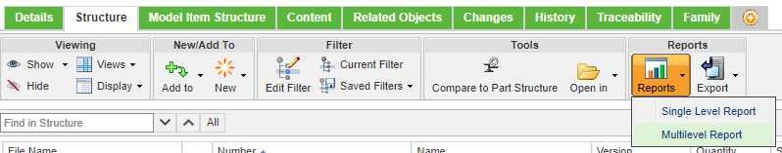

* 1. When the new window populates, click “Actions”, then “Export List it File”, then “Export List to CSV”

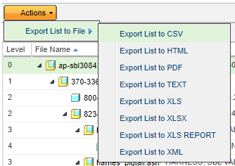

* 1. Save the CSV to a desired folder

1. Run the Parts Compiler
   1. Double click the Executable file
   2. When the file selection dialogue appears, navigate to the CSV from earlier, and select it.
   3. The program will run, and will output an excel file named “*Original File Name*_output.xlsx” in the directory that the executable is located.